INTRODUCTION OF RC CAR:
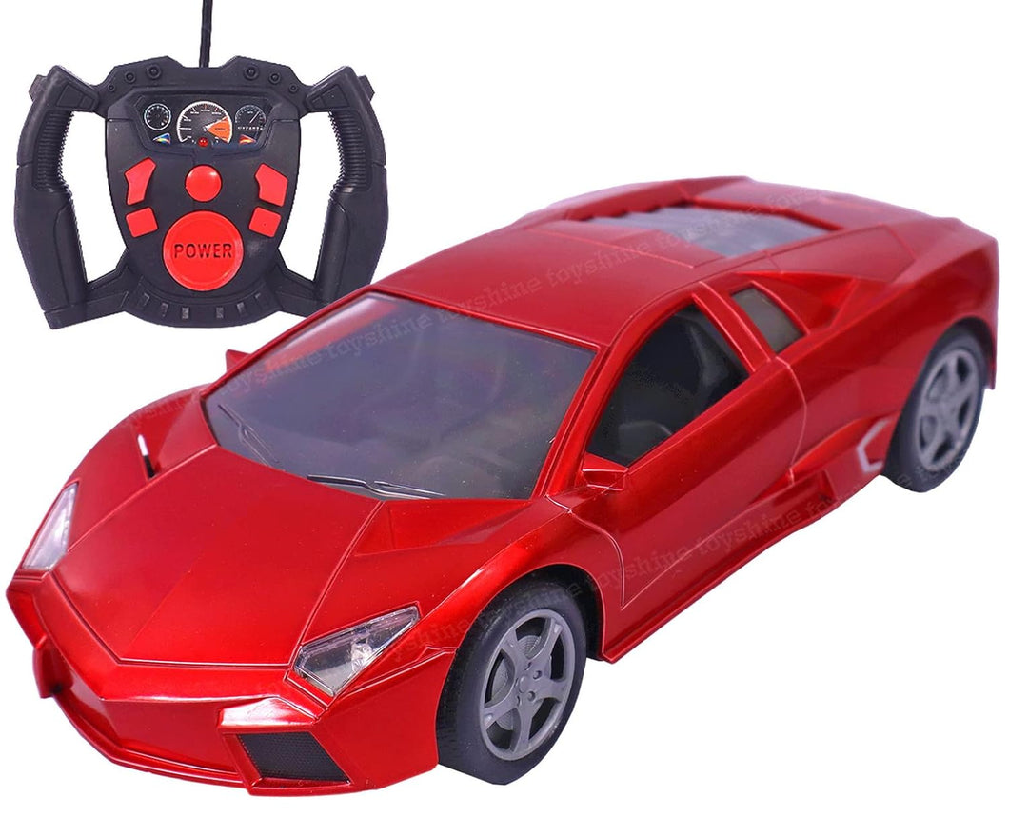
1.INTRODUCTION:
RC cars are miniature, radio-controlled vehicles, from simple toys to complex hobby models, offering fun and competition through realistic driving, with options like electric or nitro power, various scales (e.g., 1/10th), and types ranging from street cars to off-road trucks, controlled by a transmitter that sends signals to the car's receiver for steering and throttle, making them accessible for all ages but requiring care with battery management.
INTERNAL BOARD (COMPONENTS):
The RC Car Main Motherboard is a printed circuit board (PCB) that integrates:
- Signal receiver interface
- Microcontroller unit (MCU)
- Motor driver circuits
- Power management system
- Peripheral connector
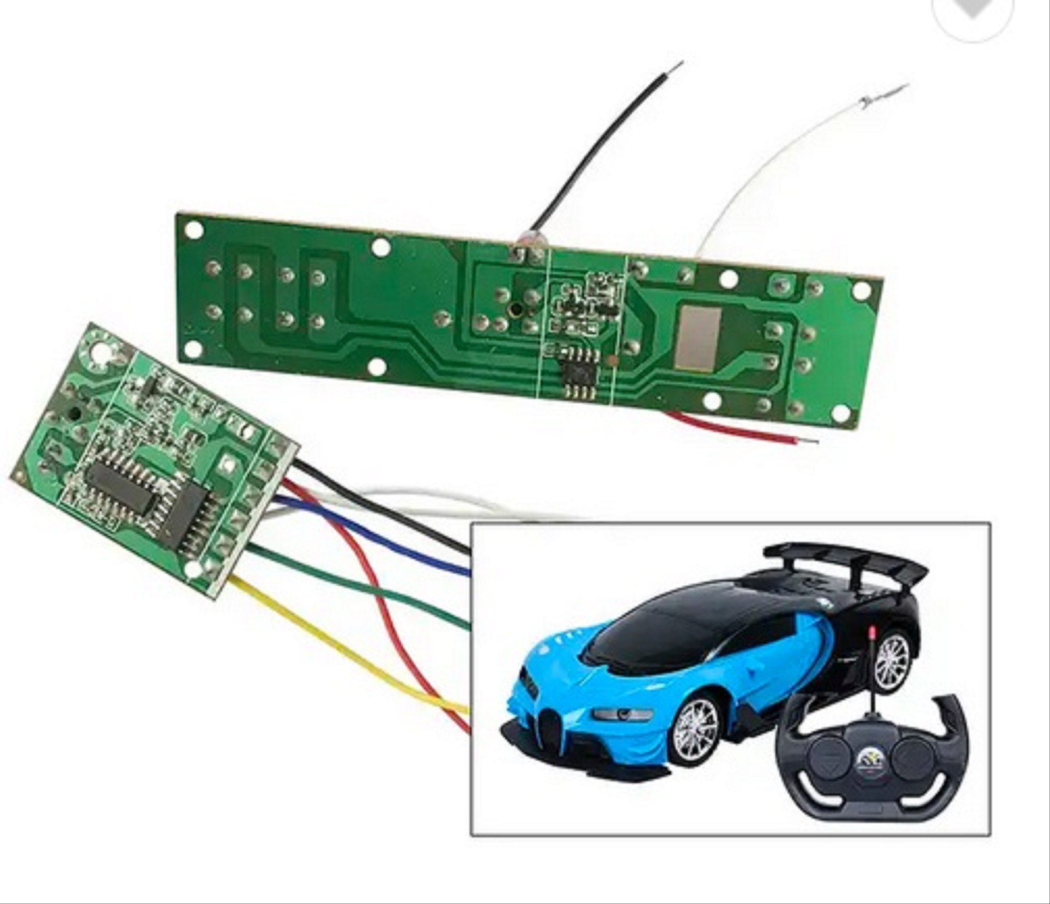
Key Components & Tech:
- Motor: Brushed (cheaper, less power) vs. Brushless (efficient, powerful, longer life).
- ESC (Electronic Speed Control): Regulates motor speed; specific to motor type (brushed/brushless).
- Transmitter & Receiver: 2.4GHz systems offer reliability and frequency hopping for clear signals.
- Servo: Controls steering.
- Battery: Lithium Polymer battery offers great performance; ensure proper handling.
Driving & Control:
- Proportional Control: Steering and throttle respond to input (more wheel/trigger = more action).
- Smooth Throttle: Avoid mashing; gentle acceleration prevents loss of control and saves battery.
- Steering Trim/Dual Rate: Adjust center steering (trim) and limit maximum steering (dual rate) for easier handling.
- Practice: Start in open areas; learn subtle inputs for turns and obstacles.
Quick Troubleshooting:
- No Power/Movement: Check battery charge, connection, and polarity.
- No Steering/Control: Check transmitter/receiver pairing (binding) and antenna.
- Erratic Steering: Check steering trim and dual rate settings.
- In essence, understand the basic electronics, practice gentle control, and look for durable, upgradeable models to enjoy the hobby.

2. Block Diagram of RC Car (Text Representation):
[Remote Transmitter]
↓ RF Signal
[Receiver Module]
↓ Control Signals
[Motor Driver / ESC]
↓ Power Control
[DC Motors / Servo Motor]
↓
[Wheels & Steering]

Battery → Motherboard → All Components

3. Main Components of an RC Car:

3.1 RC Transmitter (Remote Controller):
The RC transmitter is the handheld device used by the user to control the car.
Functions:
- Sends wireless control signals
- Controls speed, direction, and steering
Main Parts:
- Joystick / Control buttons
- RF antenna
- Control IC
- Battery compartment

3.2 RC Receiver Module:
The receiver is mounted inside the RC car and receives signals from the transmitter.
Functions:
- Receives RF signals
- Decodes control commands
- Sends signals to motor driver
Common Frequencies:
- 27 MHz, 49 MHz
- 2.4 GHz (modern RC cars)

3.3 Motherboard (Main Control Board):
The motherboard is the heart of the RC car. It connects and controls all components.
Functions:
- Power distribution
- Signal processing
- Component coordination
Main Parts on Motherboard:
- Microcontroller IC
- Motor driver IC (L293D / L298N)
- Voltage regulators
- Capacitors and resistors
3.4 Motor Driver (ESC):
The motor driver controls the speed and direction of the motors.
Functions:
- Converts low-power signals to high-power motor output
- Enables forward, reverse, left, and right movement
Common Motor Drivers:
- L293D
- L298N
- Electronic Speed Controller (ESC)

3.5 DC Motors:
DC motors provide the motion required to move the RC car.
Types Used:
- Brushed DC motors
- Gear DC motors (for torque)
Functions:
- Rear motors: Forward and backward motion
- Front motor: Steering control (in some models)

3.6 Servo Motor (Steering Motor):
A servo motor is used for accurate steering control.
Functions:
- Turns wheels left or right
- Provides precise angle control
Operating Voltage: 4.8V – 6V

3.7 Battery and Power System:
The battery supplies electrical power to the entire RC car.
Types of Batteries Used:
- AA batteries
- Li-ion battery
- Li-Po battery
Functions:
- Powers motors
- Powers control electronics

3.8 Chassis and Wheels:
The chassis is the mechanical frame that holds all components.
Functions:
- Supports electronics
- Protects components
- Provides stability
Wheel Types:
- Rubber wheels (grip)
- Plastic wheels (lightweight)

4. Working Principle of RC Car:
- User moves joystick on transmitter
- RF signal is transmitted wirelessly
- Receiver receives the signal
- Motherboard processes command
- Motor driver activates motors
- Car moves in desired direction

5. Advantages of RC Car:
- Easy to control
- Helps learn electronics and robotics
- Wireless operation
- Customizable design

6. Applications of RC Car:
- Educational projects
- Robotics competitions
- Hobby and entertainment
- Military and surveillance prototypes
Advantages of RC Cars (General & Specific)
- Skill Development: Boosts hand-eye coordination, spatial awareness, patience, and problem-solving.
- Accessibility: Electric RC cars are simple (plug-and-play), quiet, clean, and great for beginners/urban areas, with waterproof options.
- Realism & Power (Gas/Nitro): Gas models offer realistic sounds, smoke, and high power/speed with longer, uninterrupted run times (refuel only).
- Customization: Kits allow deep learning and custom part upgrades, teaching mechanics.
- Durability: Modern electrics can be durable and handle various terrains.

